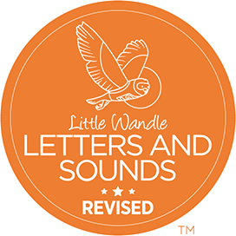
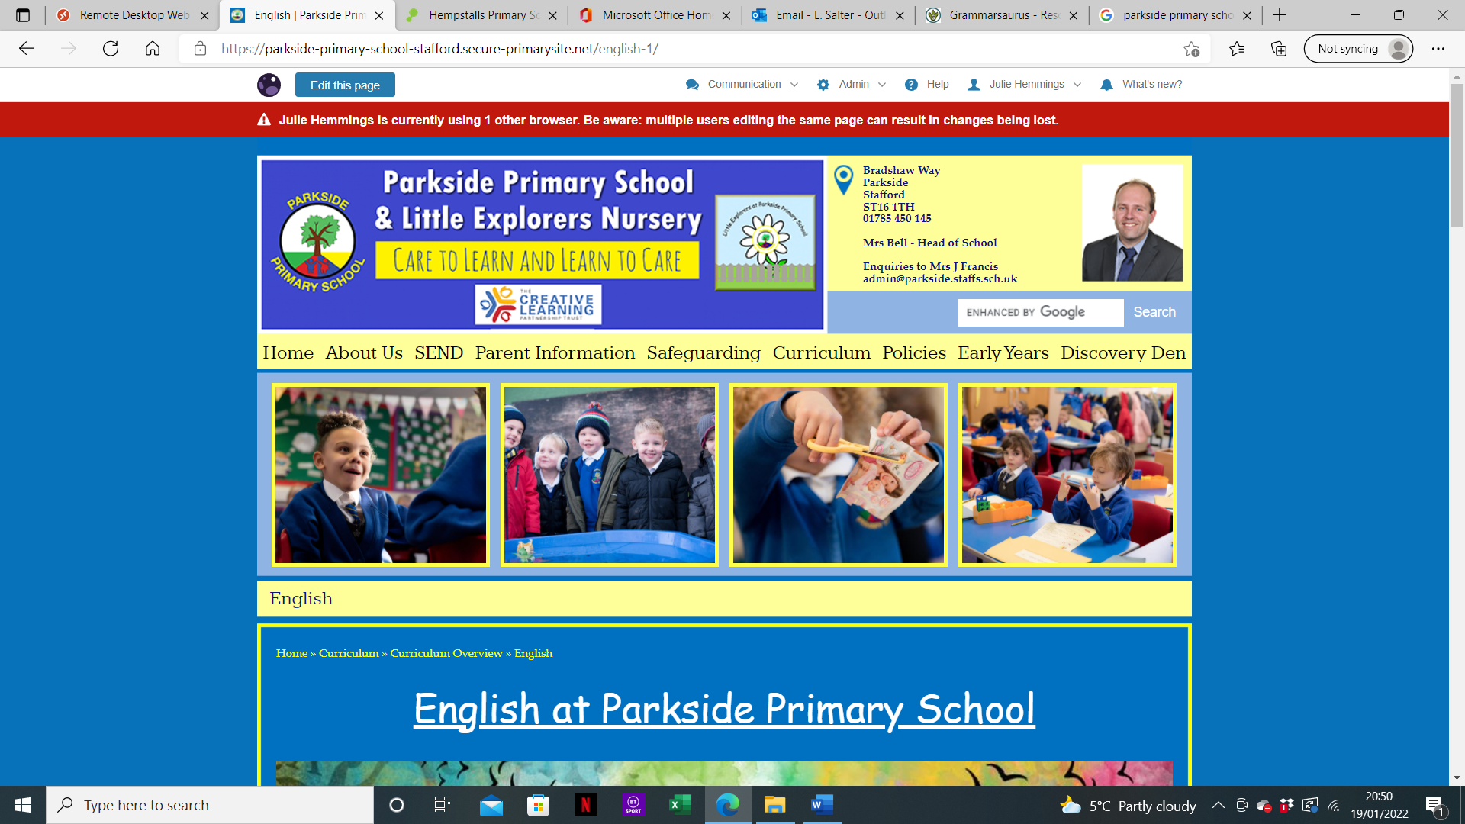

Early Reading & Phonics Policy
At Parkside Primary School, synthetic phonics is taught as our approach to early reading. Regular phonics sessions are taught from Nursery through to Year two.
Intent
Phonics (reading and spelling)
At Parkside Primary School, we believe that all our children can become fluent readers and writers. This is why we teach reading through Little Wandle Letters and Sounds Revised, which is a systematic and synthetic phonics programme. We start teaching phonics in Reception and follow the Little Wandle Letters and Sounds Revised progression, which ensures children build on their growing knowledge of the alphabetic code, mastering phonics to read and spell as they move through school. Our Nursery children receive daily immersion into phase one phonics preparing them for a smooth transition into their phonics lessons in Reception.

As a result, all our children can tackle any unfamiliar words as they read. At Parkside Primary School, we also model the application of the alphabetic code through phonics in shared reading and writing, both inside and outside of the phonics lesson and across the curriculum. We have a strong focus on language development for our children because we know that speaking and listening are crucial skills for reading and writing in all subjects.

Comprehension
At Parkside, we value reading as a crucial life skill. By the time children leave us, they read confidently for meaning and regularly enjoy reading for pleasure. Our readers are equipped with the tools to tackle unfamiliar vocabulary. We encourage our children to see themselves as readers for both pleasure and purpose.

Because we believe teaching every child to read is so important, we have a Reading Leader who drives the early reading programme in our school. This person is highly skilled at teaching phonics and reading, and they monitor and support our reading team, so everyone teaches with fidelity to the Little Wandle Letters and Sounds Revised programme.

Implementation
Foundations for phonics
- We provide a balance of child-led and adult-led experiences for all children that meet the curriculum expectations for ‘Communication and language’ and ‘Literacy’. These include:
  - sharing high-quality stories and poems
  - learning a range of nursery rhymes and action rhymes (see progression document attached)
  - activities that develop focused listening and attention, including oral blending
  - attention to high-quality language.
- We ensure children are well prepared to begin learning grapheme-phoneme correspondences (GPCs) and blending in Reception.

Daily phonics lessons in Reception and Year 1
- We teach phonics for 30 minutes a day. In Reception, we build from 10-minute lessons, with additional daily oral blending games, to the full-length lesson as quickly as possible. Each Friday, we review the week’s teaching to help children become fluent readers.
- Children make a strong start in Reception: teaching begins in Week 2 of the Autumn term.
- We follow the Little Wandle Letters and Sounds Revised expectations of progress:
  - Children in Reception are taught to read and spell words using Phase 2 and 3 GPCs, and words with adjacent consonants (Phase 4) with fluency and accuracy.
  - Children in Year 1 review Phase 3 and 4 and are taught to read and spell words using Phase 5 GPCs with fluency and accuracy.

Daily Keep-up lessons ensure every child learns to read
- Any child who needs additional practice has daily keep-up support, taught by a fully trained adult. Keep-up lessons match the structure of class teaching, and use the same procedures, resources and mantras, but in smaller steps with more repetition, so that every child secures their learning.
- We timetable phonics lessons for any child in Years 2 or 3 who are not fully fluent at reading or has not passed the Phonics Screening Check. These children urgently need to catch up, so the gap between themselves and their peers does not widen. We use the Little Wandle Letters and Sounds Revised assessments to identify the gaps in their phonic knowledge and teach to these using the Keep-up resources – at pace.
- If any child in Year 3 to 6 has gaps in their phonic knowledge when reading or writing, we plan phonics ‘catch-up’ lessons to address specific reading/writing gaps. These short, sharp lessons last 10 minutes and take place on a regular basis.

Teaching reading: Reading practice sessions three times a week
- We teach children to read through reading practice sessions three times a week. These:
  - are taught by a fully trained adult to small groups of approximately six children
  - use books matched to the children’s secure phonic knowledge using the Little Wandle Letters and Sounds Revised assessments and book matching grids on pages 11–20 of ‘Application of phonics to reading’
  - are monitored by the class teacher, who rotates and works with each group on a regular basis.
- Each reading practice session has a clear focus, so that the demands of the session do not overload the children’s working memory. The reading practice sessions have been designed to focus on three key reading skills:
  - decoding
  - prosody: teaching children to read with understanding and expression
  - comprehension: teaching children to understand the text.
- In Reception these sessions start in Week 4. Children who are not yet decoding have daily additional blending practice in small groups, so that they quickly learn to blend and can begin to read books.
- In Year 2 and 3, we continue to teach reading in this way for any children who still need to practise reading with decodable books.

Home reading
- The decodable reading practice book is taken home to ensure success is shared with the family.
- Reading for pleasure books also go home for parents to share and read to children.
- We use the Little Wandle Letters and Sounds Revised parents’ resources to engage our families and share information about phonics, the benefits of sharing books, how children learn to blend and other aspects of our provision, both online and through workshops.

Additional reading support for vulnerable children
- Children in Reception and Year 1 who are receiving additional phonics Keep-up sessions read their reading practice book to an adult daily.

Ensuring consistency and pace of progress
- Every teacher in our school has been trained to teach reading, so we have the same expectations of progress. We all use the same language, routines and resources to teach children to read so that we lower children’s cognitive load.
- Weekly content grids map each element of new learning to each day, week and term for the duration of the programme.
- Lesson templates, prompt cards and how to videos ensure teachers all have a consistent approach and structure for each lesson.
- The Reading Leader and SLT use the audit and prompt cards to regularly monitor and observe teaching; they use the summative data to identify children who need additional support and gaps in learning.

Ensuring reading for pleasure
‘Reading for pleasure is the single most important indicator of a child’s success.’ (OECD 2002)
‘The will influences the skill and vice versa.’ (OECD 2010)

We value reading for pleasure highly and work hard as a school to grow our Reading for Pleasure pedagogy.

- We read to children every day. We choose these books carefully as we want children to experience a wide range of books, including books that open windows into other worlds and cultures. Each classroom has their own age- appropriate basket of books which the teacher reads from at the end of the day.
- Classrooms have an inviting book corner that encourages a love for reading.
- In Reception, children have access to the reading corner every day in their free flow time and the books are continually refreshed.
- Children from Reception onwards have a home reading record. The parent/carer records comments to share with the adults in school and the adults will write in this on a regular basis to ensure communication between home and school.
- As the children progress through the school, they are encouraged to write their own comments and keep a list of the books/authors that they have read.
- The school library is made available for classes to use at protected times. Books can be taken home from our library as part of our ‘shared reading books’.
- Children can choose books from our ‘Books To Read Before You’re 12’ collection to earn stamps in their reading passports and earn prizes for reading these books.
- Children across the school have regular opportunities to engage with a wide range of Reading for Pleasure events (book fairs, author visits and workshops, national events etc).

Engaging with print and high-quality texts
Children and adults share high quality texts from Nursery up to Year 6. This engagement with books from entry is paramount to ensure children begin to have a love for stories which in turn will see them wanting to read stories for themselves as they grow older.

Adults ensure there are a range of books for children to have access to daily, stories are read throughout the day, particularly at snack times and end of the day. Adult’s role model their love for reading stories and the importance of respecting books, through the teaching of early book handling skills.

Simultaneously, children are encouraged to take an interest in the text and print themselves, meaning their desire to read (or engage) independently is increased. As Anjali Patel, (Lead Advisory Teacher) states, ‘reading requires practice and stamina’ so maintaining interest in and love for reading in the early years is essential.

Teachers plan for quality opportunities to engage in oral language discussion and comprehension ensuring children’s communication and language is developed. Young children need good oral language skills - to listen to stories and retell the story in a sequence. They need to be able to express ideas; exchange information and ask questions; recognise rhyme; and appreciate humour in nonsense rhymes.

Children have many opportunities to engage with text. Children from Reception and beyond have daily reading for pleasure time, where they are free to look at and read a range of books (fiction, non-fiction, magazines). They vote for which story they would like to have read to them at the end of the day, have access to our school library weekly and get to choose a book to take home. Staff ensure they hear children read throughout the week during the weekly reading sessions, ensuring pupil premium and SEND children are heard daily.
Whole class reading sessions and the imitation stage of Talk for Writing all support elements of reading comprehension. Children’s understanding is supported through real life experiences behind the story as well as the following strategies:
- Image and text work closely together. Teachers in the early years explore picture books with children to explore how image and text weave together to make meaning. Both still and moving images are used to develop skills that are essential to reading – inference, prediction, summarising, questioning.
- Exploring stories through play-based activities is a powerful aid to reading comprehension. Role play and reading areas in Early Years are focused on story and familiar books, and children are encouraged to revisit stories with which they have engaged previously, so that the ‘bank’ of texts is continually being revisited.
- Children in the early years are subjected to traditional tales and each class has a set list of books we want the children to know.
- Books are carefully selected by class teachers to support teaching of topics and high quality texts are chosen, along with familiar stories.

Support for struggling readers
We have teachers and teaching assistants who have been trained in identifying and helping to diagnose dyslexia.
'Dyslexia is a learning difficulty that primarily affects the skills involved in accurate and fluent word reading and spelling’.
- Characteristic features of dyslexia are difficulties in phonological awareness, verbal memory and verbal processing speed.
- Dyslexia occurs across the range of intellectual abilities.
- It is best thought of as a continuum, not a distinct category, and there are no clear cut-off points.
- Co-occurring difficulties may be seen in aspects of language, motor co-ordination, mental calculation, concentration and personal organisation, but these are not, by themselves, markers of dyslexia.
Strategies are put in place for those with dyslexic tendencies in line with our policy on supporting children with Special Educational Needs. Those struggling with phonetic awareness are supported through keep up intervention and struggling comprehends receive oral language comprehension sessions, in which skilled support staff provide extra opportunities to engage with text and explore meaning. Those children who do not receive support with reading in the home are targeted for extra support within school, and this is rigorously monitored by teachers.

Incentivising reading
The school has heavily invested in incentives for reading: children receive prizes as part of our ‘Books to Read Before You’re 12’ collection.
Children are rewarded with dojo points and raffle tickets if they read at least 4 times a week and it is signed in their homework diaries.
We celebrate World Book Day every year and take part in various reading challenges/sponsored reads.
Everything we do is to instil a love and passion of reading for all our children.

Parental Involvement
Parents are key in promoting the importance and love of reading for our children. We work in partnership with our parents daily.

We use the Little Wandle Letters and Sounds Revised parents’ resources to engage our families and share information about phonics, the benefits of sharing books, how children learn to blend and other aspects of our provision, both online and through workshops.

Teachers at Parkside Primary School will ensure that all parents understand how important it is to teach their children to read and to comprehend what they are reading. Reading tips/recommended books are sent out on the school newsletter and phonics sounds and words are sent out each week in Reception and KS1 for the children to practise and for the parents to know what the children have been learning with regards to their phonics and reading. We hold reading workshops for parents to help support the application of reading at home.

Impact
Assessment
Assessment is used to monitor progress and to identify any child needing additional support as soon as they need it.
- Assessment for learning is used:
  - daily within class to identify children needing keep-up support
  - weekly in the Review lesson to assess gaps, address these immediately and secure fluency of GPCs, words and spellings.
- Summative assessment is used:
  - every six weeks to assess progress, to identify gaps in learning that need to be addressed, to identify any children needing additional support and to plan the Keep-up support that they need.
  - by SLT and scrutinised through the Little Wandle Letters and Sounds Revised assessment tracker, to narrow attainment gaps between different groups of children and so that any additional support for teachers can be put into place.

Statutory assessment
- Children in Year 1 sit the Phonics Screening Check. Any child not passing the check re-sits it in Year 2.

Ongoing assessment for catch-up
- Children in Year 2 to 6 are assessed through their teacher’s ongoing formative assessment as well as through the half-termly Little Wandle Letters and Sounds Revised summative assessments.

Continual Professional Development
All new staff to the school meet with our English leader to ensure they are clear with how we teach reading. They receive phonics training from our Reading Leader and through the Little Wandle CPD Modules. All current staff have completed the Little Wandle training modules; they have access to the ‘how to’ videos for any extra support.
All staff receive phonics training and reading training regularly during staff meetings. Our English leader and reading leader ensure new initiatives are disseminated throughout the school to ensure we provide our children with the best start to their reading journey.

Ultimately, everything we do is to instil a love and passion of reading for all our children at Parkside.

Nursery Rhyme Progression across EYFS
Nursery rhymes are a core element of our curriculum with the Early Years Foundation Stage. Nursery children will learn basic nursery rhymes, some of which will be repeated in Reception to ensure that pupils are fluent whilst developing their communication, language and early literacy skills. In Nursery, children will take part in a daily Nursery Rhyme teaching and learning session which will be enhanced through the use of props and actions. Nursery children will have a Nursery Rhyme pack to further enhance their learning at home. Reception children will also sing songs and recite Nursery Rhymes throughout their day.
 | Nursery |  | Reception
Autumn 1 | Nursery Rhymes | Humpty Dumpty  Baa Baa black sheep  Row row row your boat | Nursery Rhymes | Pat-a-cake  1, 2, 3, 4, 5, Once I Caught a Fish Alive This Old Man  Five Little Ducks
Autumn 1 | Action Songs | Twinkle twinkle  Dingle Dangle Scarecrow | Action Songs | Name Song  Things For Fingers
Autumn 2 | Nursery Rhymes | Incy wincy  Old McDonald  Hickory Dickory Dock | Nursery Rhymes | I’m A Little Teapot  The Grand Old Duke Of York  Ring O’ Roses  Hickory Dickory Dock
Autumn 2 | Action Songs | The grand old duke of York  Clap your hands | Action Songs | Not Too Difficult  The ABC Song
Spring 1 | Nursery Rhymes | Wind the bobbin up  It’s raining, it’s pouring  Pat-a-cake | Nursery Rhymes | Wind The Bobbin Up  Rock-a-bye Baby  Five Little Monkeys Jumping On The Bed  Twinkle Twinkle
Spring 1 | Action Songs | Teddy bear, teddy bear  If you’re happy and you know it… | Action Songs | If You're Happy And You Know It  Head, Shoulders, Knees And Toes
Spring 2 | Nursery Rhymes | Polly put the kettle on  Hey Diddle Diddle  Jack and Jill | Nursery Rhymes | Old Macdonald  Incy Wincy Spider  Baa Baa Black Sheep  Row, Row, Row Your Boat
Spring 2 | Action Songs | The wheels on the bus  Sleeping bunnies | Action Songs | The Wheels On The Bus  The Hokey Cokey
Summer 1 | Nursery Rhymes | 5 little speckled frogs  Little bo peep (first verse)  Miss Polly had a Dolly | Nursery Rhymes | Three blind mice  10 in the bed  The animals went in two by two  The Farmer’s in his Den
Summer 1 | Action Songs | One finger one thumb | Action Songs | A sailor went to see  When I was one…
Summer 2 | Nursery Rhymes | 1, 2, 3, 4, 5, Once I Caught a Fish Alive  5 little ducks  See Saw | Nursery Rhymes | Frere Jacques  London Bridge  Sing a song of sixpence  10 green bottles
Summer 2 | Action Songs | Open shut them Here we go round the mulberry bush | Action Songs | The penguin song  Down in the jungle

