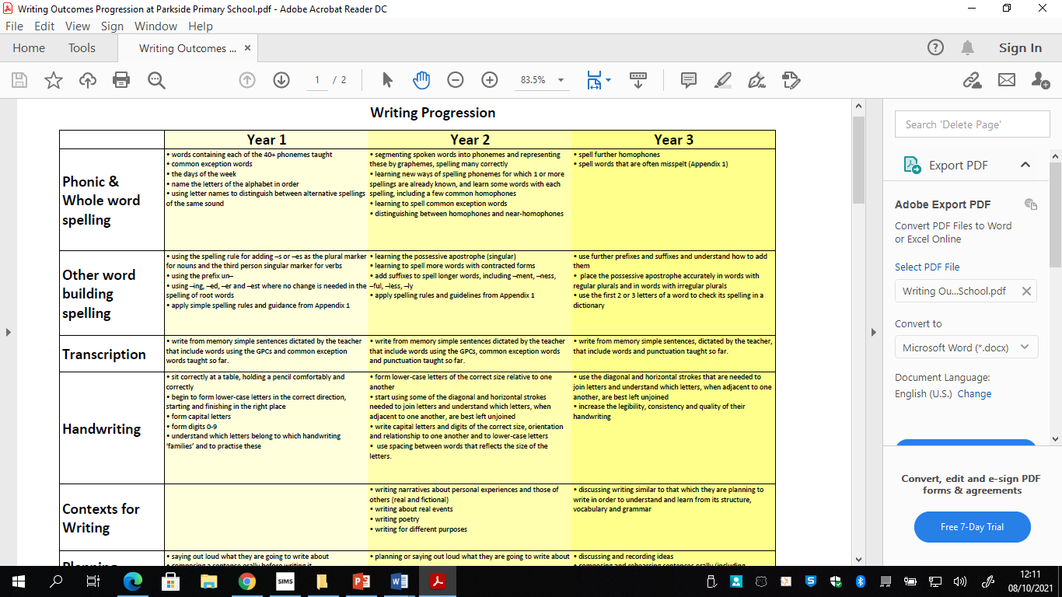
English Progression at Parkside Primary School

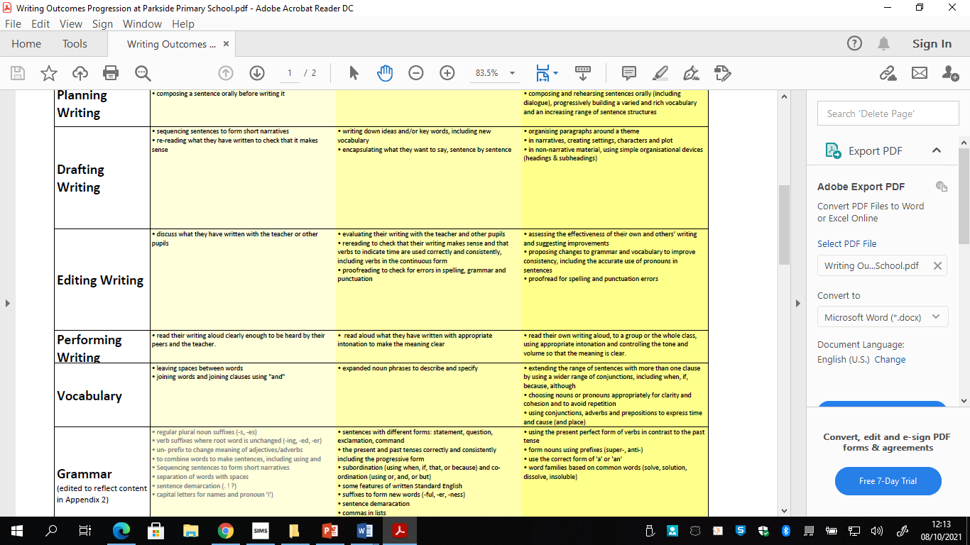
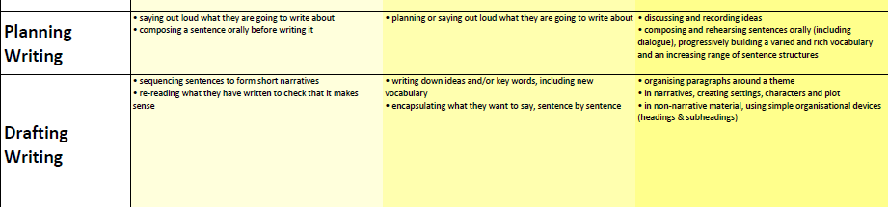

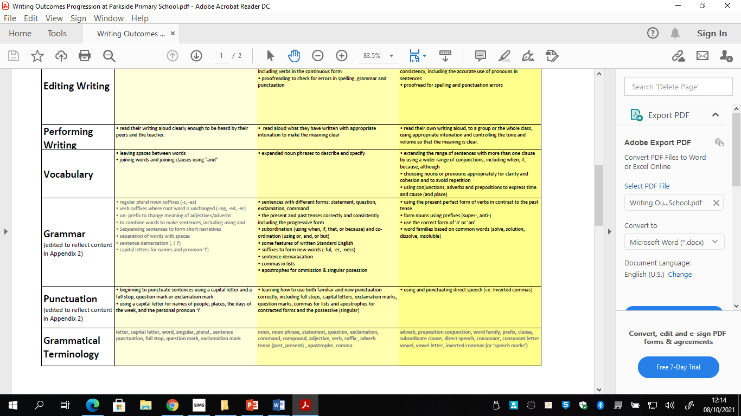

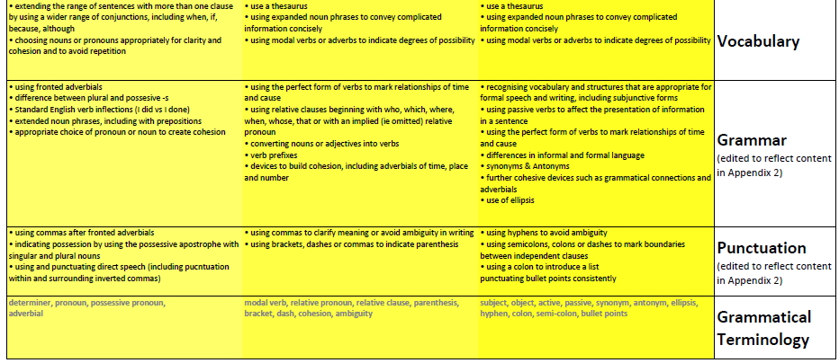
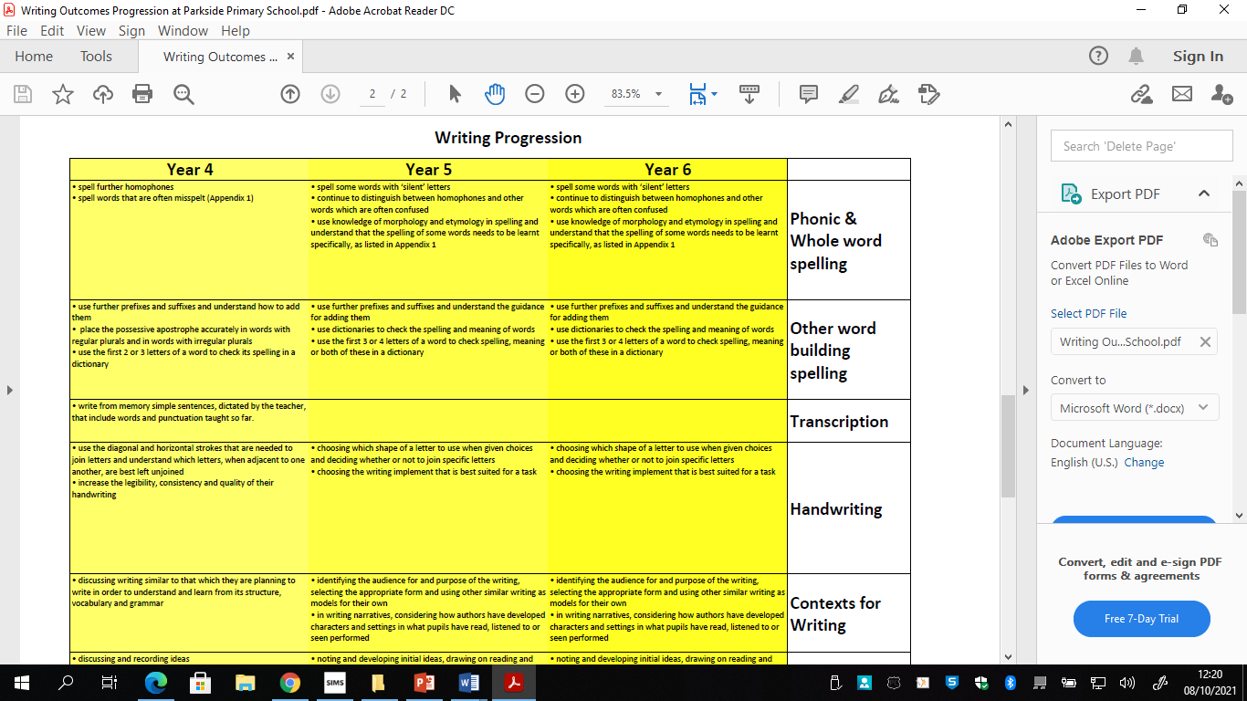

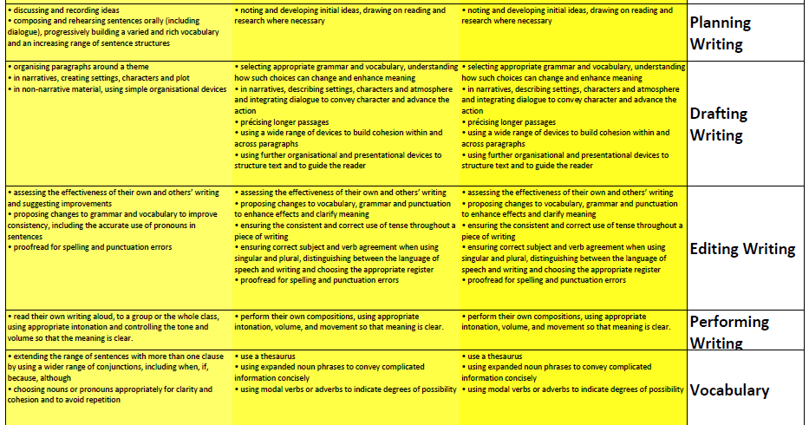

Spoken language
Pupils should be taught to:
- listen and respond appropriately to adults and their peers

- ask relevant questions to extend their understanding and knowledge

- use relevant strategies to build their vocabulary

- articulate and justify answers, arguments and opinions

- give well-structured descriptions, explanations and narratives for different purposes, including for expressing feelings

- maintain attention and participate actively in collaborative conversations, staying on topic and initiating and responding to comments

- use spoken language to develop understanding through speculating, hypothesising, imagining and exploring ideas

- speak audibly and fluently with an increasing command of Standard English

- participate in discussions, presentations, performances, role play/improvisations and debates

- gain, maintain and monitor the interest of the listener(s)

- consider and evaluate different viewpoints, attending to and building on the contributions of others

- select and use appropriate registers for effective communication

