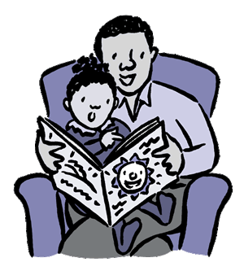
10 Tips on Hearing Your Child Read

As parents you are your child's most influential teacher with an important part to play in helping your child to learn to read.
Here are some suggestions on how you can help to make this a positive experience.

1. Choose a quiet time
Set aside a quiet time with no distractions. Ten to fifteen minutes is usually long enough.

2. Make reading enjoyable
Make reading an enjoyable experience. Sit with your child. Try not to pressurise if he or she is reluctant. If your child loses interest then do something else.

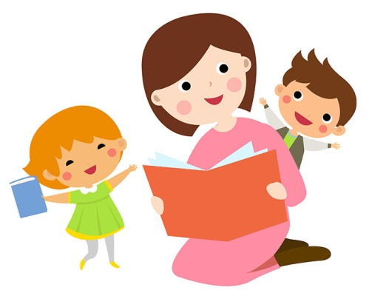
3. Maintain the flow
If your child mispronounces a word do not interrupt immediately. Instead allow opportunity for self-correction. It is better to tell a child some unknown words to maintain the flow rather than insisting on trying to build them all up from the sounds of the letters. If your child does try to 'sound out' words, encourage the use of letter sounds rather than 'alphabet names'.

4. Be positive
If your child says something nearly right to start with that is fine. Don't say 'No. That's wrong,' but 'Let's read it together' and point to the words as you say them. Boost your child's confidence with constant praise for even the smallest achievement.

5. Success is the key
Parents anxious for a child to progress can mistakenly give a child a book that is too difficult. This can have the opposite effect to the one they are wanting. Remember 'Nothing succeeds like success'. Until your child has built up his or her confidence, it is better to keep to easier books. Struggling with a book with many unknown words is pointless. Flow is lost, text cannot be understood and children can easily become reluctant readers.

6. Visit the Library
Encourage your child to use the public library regularly.

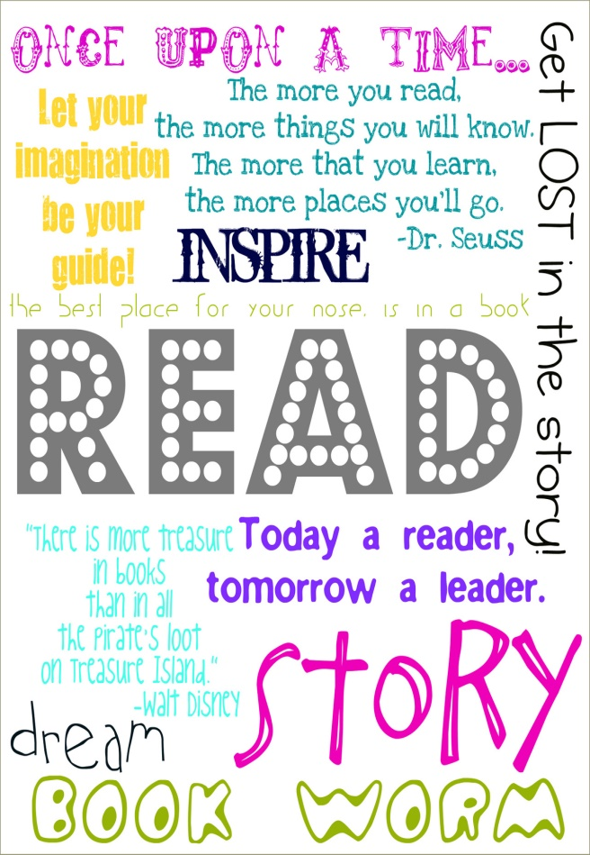
7. Regular practice
Try to read with your child on most school days. 'Little and often' is best. Teachers have limited time to help your child with reading.

8. Communicate
Your child will most likely have a reading diary from school. Try to communicate regularly with positive comments and any concerns. Your child will then know that you are interested in their progress and that you value reading.

9. Talk about the books
There is more to being a good reader than just being able to read the words accurately. Just as important is being able to understand what has been read. Always talk to your child about the book; about the pictures, the characters, how they think the story will end, their favourite part. You will then be able to see how well they have understood and you will help them to develop good comprehension skills.

10. Variety is important
Remember children need to experience a variety of reading materials eg. picture books, hard backs, comics, magazines, poems, and information books.


