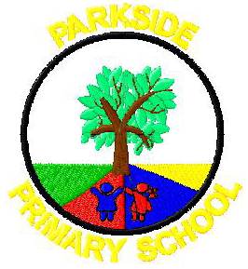
QUESTIONS FOR READING
Below you will find a list of possible questions to help you with conversations about your child’s reading. They are not intended to be used all at once or every time you read with your child. Use them at your discretion and where they are appropriate. Happy reading!
Questions to ask before you read
- Can you look at the pictures and predict what you think will happen in this book?
- What makes you think that?
- What characters do you think might be in our story?
- Do you think there will be a problem in this story? Why or why not?
- Does the topic/story relate to you or your family? How?
Questions to ask during the reading
- What do you think will happen next?
- What can you tell me about the story so far?
- Can you predict how the story will end?
- Why do you think the character did _______?
- What would you have done if you were the character?
- How would you have felt if you were the character? (use different characters)
- As I read____________, it made me picture________ in my head. What pictures do you see in your head?
- As you read, what are you wondering about?
- Can you put what you’ve just read in your own words?
Questions to ask after reading
- Can you remember the title?
- In your opinion, was it a good title for this book? Why or why not?
- Were your predictions about the story correct?
- If there was a problem, did it get solved?
- What happened because of the problem?
- Why do you think the author wrote this book?
- What is the most important point the author is trying to make in his writing?
- What was your favorite part of the story?
- If you could change one thing in the story, what would it be?
- Can you retell the story in order?
- If you were __________, how would you have felt?
- What is the most interesting situation in the story?
- Is there a character in the story like you? How are you alike?
- Why did you like this book?

REF: http://iusd.org/parent_resources/questionsencourage.htm

