Parkside Primary School – PSHE / RSE Progression

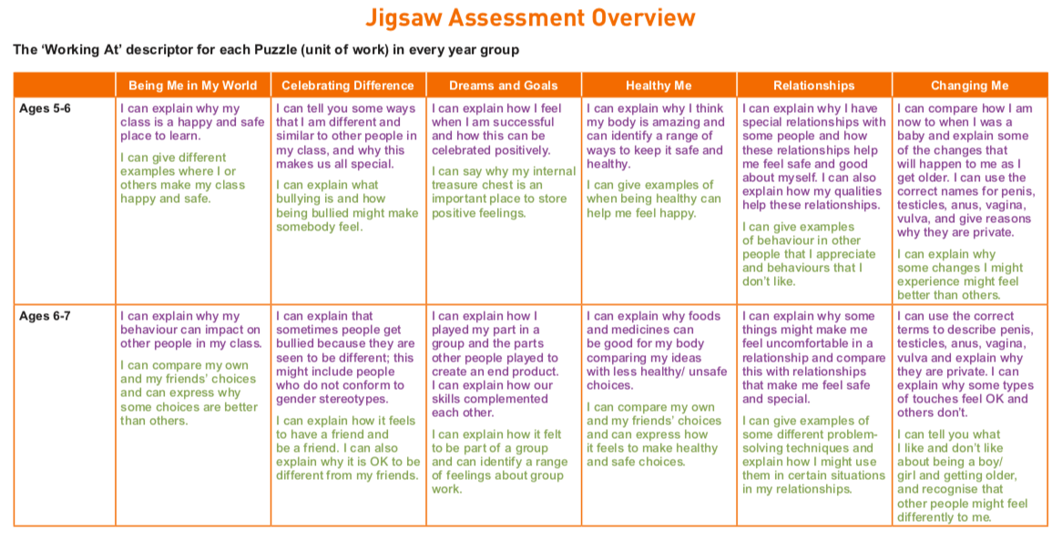
Autumn 1. Autumn 2 Spring 1 Spring 2 Summer 1 Summer 2

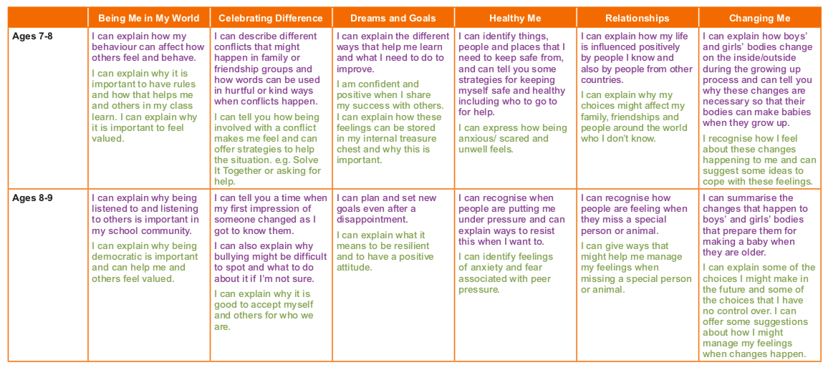
Autumn 1. Autumn 2 Spring 1 Spring 2 Summer 1 Summer 2

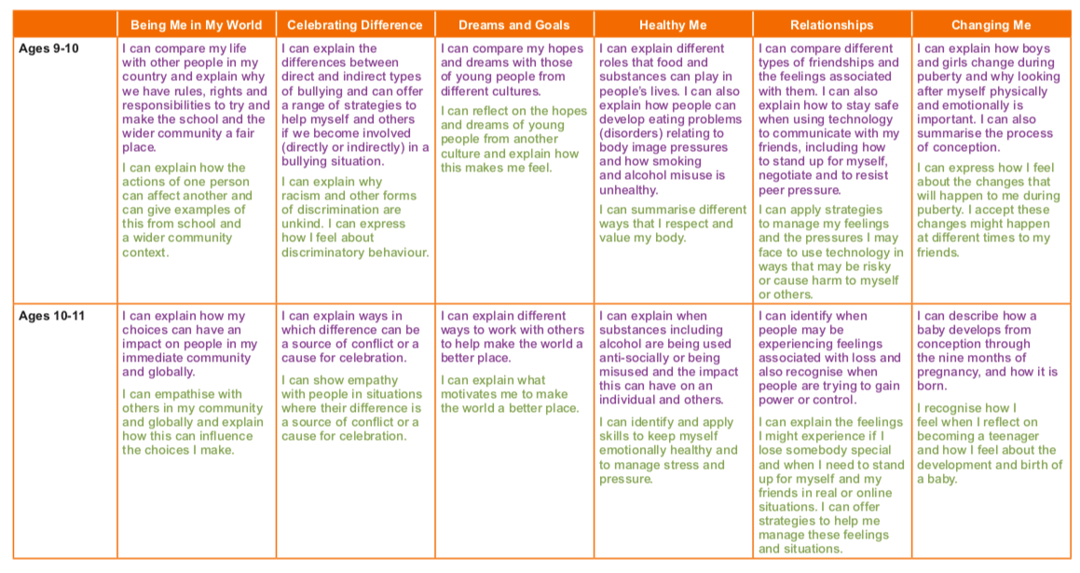
Autumn 1. Autumn 2 Spring 1 Spring 2 Summer 1 Summer 2

